Unit 1, Lesson 4: Practice Problems
- Select all the statements that must be true for any scaled copy Q of Polygon P.
- 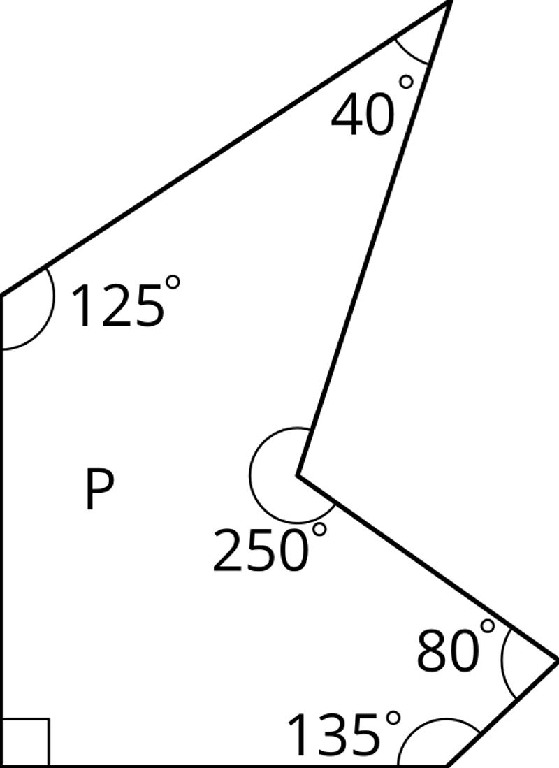
  - The side lengths are all whole numbers.
  - The angle measures are all whole numbers.
  - Q has exactly 1 right angle.
  - If the scale factor between P and Q is $\frac{1}{5}$, then each side length of P is multiplied by $\frac{1}{5}$ to get the corresponding side length of Q.
  - If the scale factor is 2, each angle in P is multiplied by 2 to get the corresponding angle in Q.
  - Q has 2 acute angles and 3 obtuse angles.
- Here is Quadrilateral $ABCD$.
- 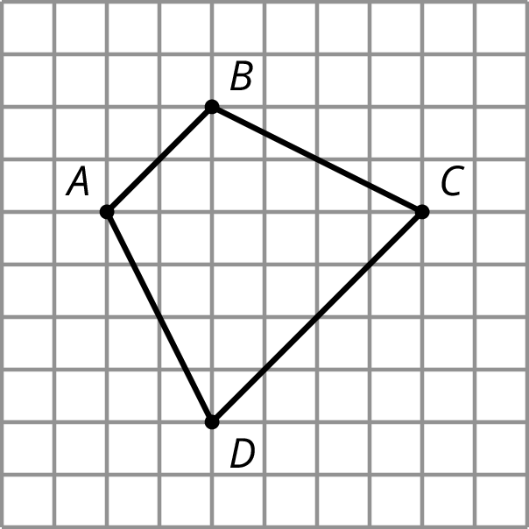
- Quadrilateral $PQRS$ is a scaled copy of Quadrilateral $ABCD$. Point $P$ corresponds to $A$, $Q$ to $B$, $R$ to $C$, and $S$ to $D$.
- If the distance from $P$ to $R$ is 3 units, what is the distance from $Q$ to $S$? Explain your reasoning.
- Figure 2 is a scaled copy of Figure 1.
- 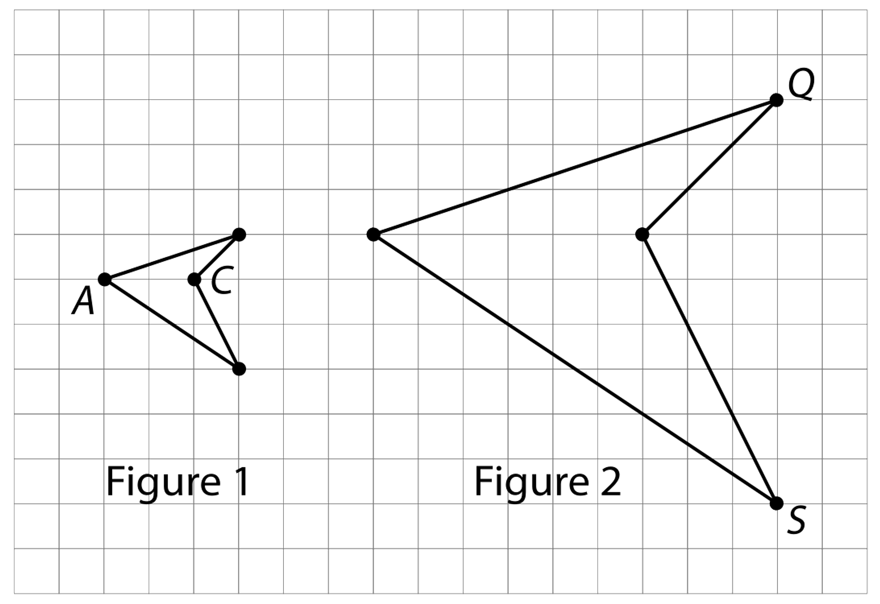
  - Identify the points in Figure 2 that correspond to the points $A$ and $C$ in Figure 1. Label them $P$ and $R$. What is the distance between $P$ and $R$?
  - Identify the points in Figure 1 that correspond to the points $Q$ and $S$ in Figure 2. Label them $B$ and $D$. What is the distance between $B$ and $D$?
  - What is the scale factor that takes Figure 1 to Figure 2?
  - $G$ and $H$ are two points on Figure 1, but they are not shown. The distance between $G$ and $H$ is 1. What is the distance between the corresponding points on Figure 2?
- To make 1 batch of lavender paint, the ratio of cups of pink paint to cups of blue paint is 6 to 5. Find two more ratios of cups of pink paint to cups of blue paint that are equivalent to this ratio.

